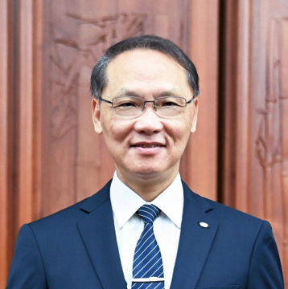
Po-Wen Yen
Born in October 1956
Current position: CEO of Taiwan Buddhist Tzu Chi Charity Foundation
Director at Tzu Chi Charity Foundation
Education: Master of Chemical Engineering from National Taiwan University, Bachelor of Chemical Engineering from Tsinghua University

Experience:
- CEO of Taiwan Buddhist Tzu Chi Charity Foundation from July 2017 to present
- CEO of United Microelectronics Corporation from November 2012 to June 2017
Honors:
- Awarded "2018 Tsinghua University Outstanding Alumni" (2018)
- Awarded the "SEMI Sustainable Manufacturing Leadership Award" (2016)
- Awarded "Top Ten Outstanding Managers Award" (2003)

Po-Wen Yen joined UMC (the world's third-largest semiconductor manufacturing company) in 1986, became CEO in 2012, and retired in 2017. During his time at UMC, he led by example and, based on the concepts of quality, innovation, and corporate sustainability, led the team to continue to make breakthroughs, establish benchmarks, and encouraged colleagues to actively participate in social welfare activities.

Since becoming a Tzu Chi volunteer, he has personally participated in international disaster relief, practiced environmental recycling, and called for the sustainable development of the earth. "We all know and understand that we must start from ourselves." In 2017, in the spirit of "if you don't do it for self-benefit, you will have greater motivation to persevere," he served as the CEO of the "Taiwan Buddhist Tzu Chi Charity Foundation."

Tzu Chi Foundation was founded by Master Cheng Yen in 1966. It is committed to eradicating poverty and hunger, disaster relief and humanitarian relief, funding children's education, community elder care, environmental protection and education, global cooperation, and sustainable development. As of January 2024, the Tzu Chi Foundation’s global assistance covers 133 countries and regions. When the COVID-19 epidemic hit the world in 2020, Tzu Chi provided more than 38.48 million pieces of anti-epidemic aid materials in 93 countries and regions around the world; it also distributed relief supplies in 41 countries and regions, benefiting a total of 2.14 million households /8.96 million people.

Combining his experience and influence in technology and charity groups, CEO Yan promotes internal control optimization, information disclosure, and global certification. Based on the United Nations' 17 sustainable development goals, he sets a sustainable development vision for Tzu Chi and becomes a model for global religious charities. Advance.

We strive to be transparent and open, publishing the Tzu Chi Sustainability Report in Chinese and English. The following awards recognized the effort:
- the Elite Award at the 2020 SGS Corporate Social Responsibility Awards in Taiwan
- Gold Award and Social Inclusion Award for the TCSA (Taiwan Corporate Sustainability Award) in the corporate sustainability reporting category for the government and NGOs
- National Sustainable Development Award Civil Society Sustainability Award from the National Development Council of the Executive Yuan
- 2022 TCSA Taiwan Corporate Sustainability Award
- Diversity and Inclusion Award from the 2023 SGS ESG Awards

In 2021, the Tzu Chi Foundation announced that it would promote net-zero emissions and set a carbon reduction roadmap using science-based targets (SBT), aiming to achieve net-zero emissions by 2050. On April 7, 2022, Tzu Chi officially joined the UNFCCC Climate Neutral Now Initiative to promote climate action in the international community. Aligning with the UN SDGs, developing ESG practices, and practicing corporate social responsibilities, we are committed to establishing systems and strengthening our governance structure; inheriting from tradition and cultivating talents; building global partnerships for the common good; and optimizing the use of information and funds, to strive for the sustainability of the earth and humankind.

